***Happiness in the year to come.***

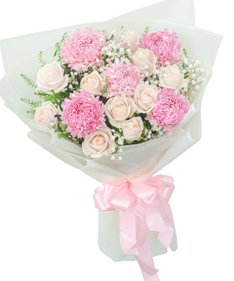

*In feng shui, yellow is very suitable for weddings and festivals. It also symbolizes Fire energy and strength... The congratulatory flower shelf is seriously invested by florists because we always understand that it is. is the reputation of customers, of an entire business.We always receive the love from customers, especially businesses who trust and order floral designs to celebrate the opening, inauguration, organize events and in other important holidays.*